Assessment Schedule – 2015
Mathematics and Statistics: Apply algebraic methods in solving problems (91261)
Evidence
One | Expected Coverage | Understanding (u) | Relational thinking (r) | Abstract thinking (t)
(a)(i) | 2^{x} = 1024  x = 10 | Equation solved.
(a)(ii) | 3w + 1 = 4²  3w = 15  and w = 5 | Equation solved.
(a)(iii) | x² = 4x + 12  x² – 4x – 12 = 0  (x – 6)(x + 2) = 0  x = 6 or –2  But base must be positive  x = 6 is the only solution | Sets up a quadratic equation. | Solved problem using quadratic, but gives both values. | Gives only valid solution with justification.
(b) | 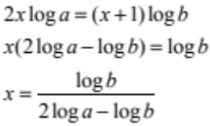 | Takes logs of both sides and multiplies by indices. | Takes logs of both sides and rearranges. | Correctly solved.
(c)(i) | P = A × (1.03)^{t}  Beginning of 1999, t = 0,  t = 16, P = 350 000  350 000 = A (1.03)¹⁶  A = 218 108  So price was $218 108 initially. | Sets up model correctly. | Answers question in context correctly.
(c)(ii) | 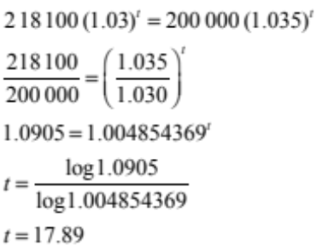  In 2016. | Set up correct equation. | Solved for t. | Correct year identified.

NØ | N1 | N2 | A3 | A4 | M5 | M6 | E7 | E8
No response; no relevant evidence. | Attempt at one question | 1 of u | 2 of u | 3 of u | 1 of r | 2 of r | 1 of t | 2 of t

Two | Expected Coverage | Understanding (u) | Relational thinking (r) | Abstract thinking (t)
(a) | 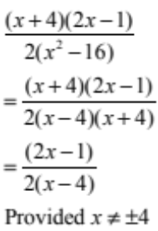 | Factorised and simplified with one error. | Correctly simplified.
(b) | 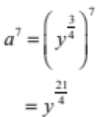 | Correct expression.
(c) | 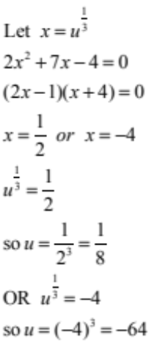 | CAO  or rewrites as quadratic. | Solves for x. | Solves completely with both solutions.
(d)(i) | Let x be the length and w the width. Then the perimeter is 2x + 2w.  Area xw = 50  So 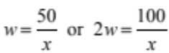  So perimeter = 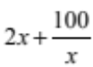 | Shows relationship.
(d)(ii) | 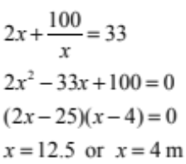  So the dimensions of the garden are 4 m and 12.5 m. | Forms a quadratic equation | Solved for x, or consistently solved from incorrect quadratic. | Correctly solved and dimensions given.
(e) | David’s speed is  x km / h  Sione’s speed is  (x + 4) km / h  Difference in time is half an hour.  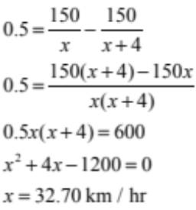 |  | Sets up equation correctly and solves with an error. | Correctly sets up equation and solves correctly.

NØ | N1 | N2 | A3 | A4 | M5 | M6 | E7 | E8
No response; no relevant evidence. | Attempt at one question | 1 of u | 2 of u | 3 of u | 1 of r | 2 of r | 1 of t | 2 of t

Three | Expected Coverage | Understanding u | Relational thinking r | Abstract Thinking t
(a)(i) | 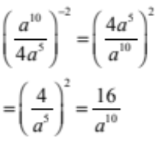 | Evidence of correctly simplifying the negative or index or square  or  numerator or denominator correct | Algebraic expression simplified.
(ii) | 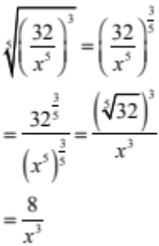 | Numerator or denominator correct. | Algebraic expression simplified.
(b) | 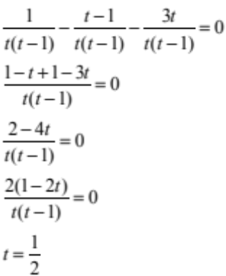 | Partially solved by rewriting over correct common denominator. | Correctly solved.
(c) | Never touch the x-axis means ∆ < 0  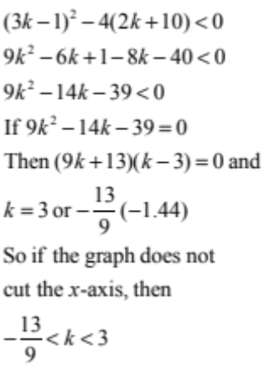 | ∆ < 0 | Correct solutions for k. | Problem solved with correct inequality.
(d) | If both roots real, so ∆ > 0  ie [–(m + 2)]² – 4m × 2 > 0  So m² – 4m + 4 > 0  i.e. (m – 2)² > o  So m can be any real number but m ≠ 2, as any number squared except zero is always positive.  Using the quadratic formula or otherwise, the roots are  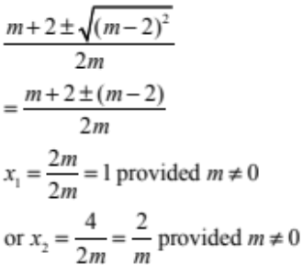  So to fill all conditions including both roots are positive real, we have m > 0 m≠2 with roots 1 and 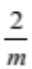. | ∆ > 0 | (m – 2)² > 0 and m ≠ 2  OR  BOTH roots found. | Problem solved correctly.

NØ | N1 | N2 | A3 | A4 | M5 | M6 | E7 | E8
No response; no relevant evidence. | Attempt at one question | 1 of u | 2 of u | 3 of u | 1 of r | 2 of r | 1 of t | 2 of t

Cut Scores
Not Achieved | Achievement | Achievement with Merit | Achievement with Excellence
0 – 7 | 8 – 14 | 15 – 19 | 20 – 24

